

Open Hydrology Courseware Using the United States Geological Survey’s National Water Census Data Portal

***Software Introduction***

Jake Nelson1, Daniel P. Ames2, David Blodgett3

1Civil and Environmental Engineering, Brigham Young University, Provo, Utah 84602, [jake.nelson7@gmail.com](mailto:jake.nelson7@gmail.com)

2Civil and Environmental Engineering, Brigham Young University, Provo, Utah 84602

3United States Geological Survey

Abstract

The United States Geological Survey (USGS) is the primary U.S. government agency for water data collection and dissemination. In this role, the USGS has recently created and deployed a National Water Census Data Portal (NWC-DP) which provides access to streamflow, evapotransporation, precipitation, aquatic biology and other data at the national level. Recognizing the value of these data sets for hydrologic science education, this paper presents an effort to bridge the gap between pencil–and-paper-based hydrology curriculum and the USGS NWC-DP resource. Specifically, we have developed an R package, National Water Census Education (NWCEd), and five associated laboratory exercises that integrate R and web services based access to the NWC-DP datasets. Using custom functions built into the NWCEd, students are able to access unprecedented amounts of hydrologic data from the NWC-DP which can be applied to current hydrology curriculum and analyzed using NWCEd and a number of other open-source R tools.

Keywords: Hydrology, Education, Software, R, National Water Census Data Portal

1.0 Introduction

As the hydrologic scientific community continues to adopt new technology, there becomes a need for educators to incorporate new technology and techniques into their curriculum (Thompson et al. 2012; Wagener et al. 2012). In hydroinformatics courses in particular, there is great potential to use online tools and data to aid the educational experience (Popescu et al. 2012). In comparison to pencil-and-paper-based laboratory assignments, data-driven laboratory exercises with interactive modeling and visualization components can improve learning and better help prepare students to enter the profession (Sanchez et al. 2016).

While there exists a plethora of new software that could be implemented in university classrooms, research has shown that many educators struggle or are averse to amending their curriculum (Merwade and Ruddell 2012). According to Merwade and Ruddell (2012), several roadblocks can contribute to this problem, including “a lack of access to easily adoptable curriculum materials and a lack of time and training to learn constantly changing tools and methods” and that implementing new technology “should emphasize conceptual learning, and should be used to complement rather than replace lecture-based pedagogies”. Indeed, in hydrologic research, reuseable code and data should be made available so that scientific results can be reproduced (Hutton et al.). Such availability of code and data is equally important in the classroom.

One specific challenge in technology-augmented learning is in the incorporation of web-based data resources, such as those provided by the U.S. Geological Survey (USGS), into an introductory hydrology course. The USGS has made many attempts to make their data holdings accessible to the general public and to scientists through, for example, The National Map (<http://www.nationalmap.gov/>) (Simley and Carswell Jr 2009), South Florida Information Access Data Exchange (<https://sofia.usgs.gov/>), the Geo Data Portal (<https://cida.usgs.gov/gdp/>) (Blodgett 2011), and Biodiversity Information Serving Our Nation (BISON) (<https://bison.usgs.gov/>) (Hanken 2013). In 2001, the USGS released a public web interface for their National Water Information System (NWIS) called USGS Water Data for the Nation (<https://waterdata.usgs.gov/nwis>). This website includes simple tutorials on navigating the website interface and methods for downloading hydrologic data. Many of the web-based data sources provided by the USGS have either examples or primers on how to use their tools, but no additional resources that could be integrated with or support current hydroscience curriculum.

The Consortium of Universities for the Advancement of Hydrologic Science, Inc. (CUASHI), has made extensive efforts to increase the academic use of USGS and other water-related, web-based data sets by educators through various initiatives, webinars, and conferences (CUAHSI 2012; Keim et al. 2014; Morsy et al. 2016; Tarboton et al. 2014; Tarboton et al. 2011). These efforts have generally focused on the CUAHSI Hydrologic Information System (Ames et al. 2009; Tarboton et al. 2009), which has included USGS NWIS data sets since its inception. CUAHSI resources include training modules that provide step-by-step instruction on how to access many data sets through CUAHSI’s HydroClient and how to create data visualizations in Microsoft Excel and RStudio (Brazil 2016a; Brazil 2016b).

Another data portal has been developed by the USGS called the National Water Census Data Portal (NWC-DP) (<https://cida.usgs.gov/nwc/>). This portal provides public access to large amounts of hydrologic data, collected through the USGS’s National Water Census (NWC) research program (<https://water.usgs.gov/watercensus/water-budgets.html>). The NWC is responsible for the collection of precipitation, evapotranspiration, and stream runoff data. Along with NWC data, web-based tools are available in the portal to provide a means whereby the data can be analyzed. NWC-DP provides support for making informed decisions affecting water availability and usage (<https://water.usgs.gov/watercensus/>). The NWC-DP, however, does not have an educational component to instruct users how to access the associated tools and data.

Missing in these efforts to communicate USGS water resources data to educators and students, is an interactive, code-based set of educational materials that integrates scripting for data access, retrieval and analysis with basic hydrologic principles. In this paper, we present the developent of the National Water Census Education R package (NWCEd) and corresponding open courseware educational laboratory exercises, which serve to fill this gap.

The remainder of this paper is organized as follows. The methods section presents a description of the development of the NWCEd package and its associated functions. A discussion on the development of five educational laboratory exercises is provided, including established learning objectives for the materials. The Results section discusses how the NWCEd technology supports the content of each of the laboratory exercises. An analysis of the correspondence between laboratory content and the established learning objectives is also included. The conclusion discusses options for future research with regards to the effectiveness of laboratory exercises in improving learning.

2.0 Methods

The National Water Census Education R-package (NWCEd) and associated laboratory exercises serve as tools that introduce hydroscience students to USGS hydrologic time series data sets, processing and analysis tools, and hands-on learning activities. This section describes the NWCEd, its associated package components and functions, and external R-packages required for complete NWCEd functionality. Discussion is also provided on the creation of the laboratory exercises.

2.1 Documentation

The NWCEd R-package was developed in RStudio (RStudio-Team 2015) and contains several custom R functions (<http://r-pkgs.had.co.nz/>), preloaded data tables, NWC-DP screenshot images, and HTML and R Markdown (.Rmd) files of the laboratory exercises. Much of the documentation was generated automatically using Roxygen2 (<https://cran.r-project.org/web/packages/roxygen2/vignettes/rd.html>), including seven Markdown (.Rd) files describing the custom-made R functions and the NAMESPACE file, which contains the list of functions made available through the package. The documentation also includes a manually created README file that provides instructions for installing the NWCEd package, laboratory content, required external R packages, links for viewing the laboratory exercises in a web browser, and licensing information (<http://water.usgs.gov/software/help/notice/>). Complete NWCEd documentation and source code is available at <https://github.com/USGS-R/NWCEd>.

2.2 Custom NWCEd R-package Functions

One of the primary objectives of the NWCEd package is to allow users to access hydrologic time series data sets from the NWC-DP in RStudio. To do this, we created custom functions to retrieve the respective data sets from a USGS server. The process is outlined in Figure 1 below.

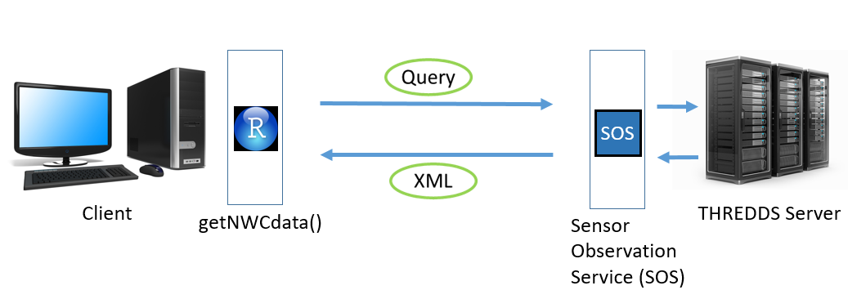

Figure 1. The getNWCdata retrieves hydrologic data from USGS servers and returns an RStudio data table to the user.

The user builds a query for a desired hydrologic data set based on a user-selected hydrologic unit code (HUC) using the getNWCdata function. Using an HTTP protocol, the query is sent to a Sensor Observation Service (SOS) web service (Jirka et al. 2012). The SOS web service retrieves the desired data set and returns it to the user formatted as XML text (Erl 2004). The getNWCdata function then parses the XML file into an RStudio data table view.

Another function, getNWCWatershed, extracts watershed geometry information from a USGS server in a similar way as the getNWCdata function. A query is built using the getNWCWatershed function and is sent using an HTTP protocol. The query interacts with the web feature service (WFS) (Peng and Zhang 2004). The WFS interacts with GeoServer to obtain a polygon feature associated with the specified HUC. A GeoJSON text file (Butler et al. 2008) containing the watershed boundary coordinates is then returned to the user and converted to a map representation for visualization. To improve visualization, the polygon fill option is turned off, subsequently displaying only the boundary of the watershed. The boundary is then laid over a base map provided by the external Leaflet R package (Graul 2016), which allows users to zoom in and out, as well as pan around the area of their desired watershed.

A Log-Pearson Type III function was developed for the purpose of teaching concepts related to hydrologic probability distributions and return periods. This function, called Lp3, implements the method described by Oregon State University (<http://streamflow.engr.oregonstate.edu/analysis/floodfreq/#log>). The Lp3 function receives two arguments: a user-named variable containing previously downloaded NWC-DP data, and a data set type such as “prcp” for precipitation or “streamflow” for streamflow data. The Lp3 function then returns a Log-Pearson Type III distribution plot. Other functionality has been provided in the NWCEd package including the annualize function, which converts time series data sets from daily time series to annual time series, and the getNWISsite, which verifies the location of aUSGS stream gage.

Table 1 lists other external open-source R packages used in this project together with each specific, respective function. A description of the application of these packages in the project is provided later under the Laboratory Exercises Development section.



Table 1. NWCEd works in concert with functionalities provided by external R packages.

Each of these packages are hosted on the Comprehensive R Archive Network (CRAN) website (R-Core-Team 2016). The packages are downloaded from CRAN into an instance of RStudio using default RStudio functions. The NWCEd package is downloaded from GitHub into an instance of RStudio using the functionality of the devtools package as listed in the table above. An illustration of the relationship between the local instance of RStudio and GitHub, CRAN, and the NWC-DP is provided as Figure 2 below.

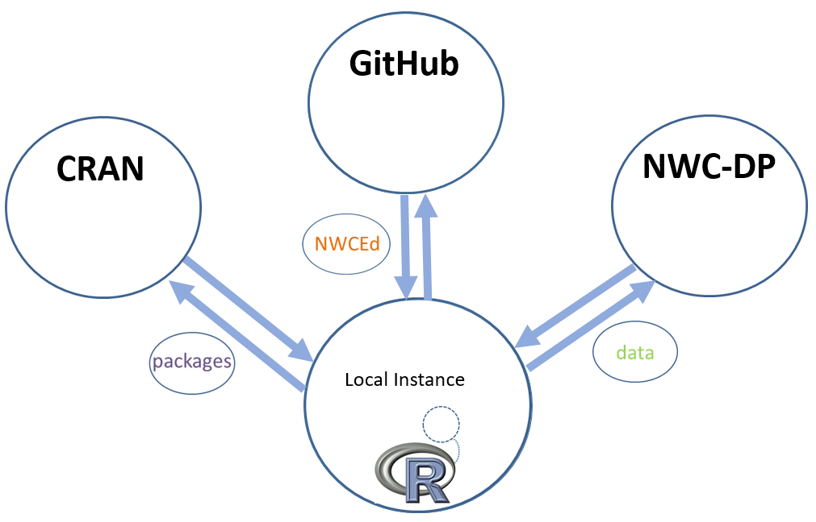

Figure 2. NWCEd, external R packages, and data from NWC-DP are downloaded into a local instance of RStudio.

2.3 Laboratory Exercises Development

A core goal of this work was to develop a set of laboratory exercises that expose the National Water Census data and web services to hydrology students and educators. These exercises were developed in RStudio. The raw content for these labs was written in html, R Markdown, and Javascript in order to achieve the desired interactive functionality. The knitr package was then used to read each of the languages and convert the contents into interactive html pages (Xie 2016).

The labs have many shared, built-in features, including layout, image display, and interactive buttons. The specific layout of the lab documents comes from an R Markdown document template. The template used for the NWCEd labs was an html template. The “cerulean” theme was selected, which corresponds to the blue font of the labs. An interactive table of contents is also a common layout feature. This feature allows the user to click on the desired section within a given lab and automatically be relocated within the document to the specified location.

Each of the five labs instructs students on how to use the NWC-DP. This is done by including several screenshots of the NWC-DP as part of the content. Relative paths for these images were coded in R Markdown into the raw document, and knitr was used to generate the images into the html documents with varying formatting styles.

Another feature of the labs is the ability to toggle code blocks, hints, and answers to questions using Javascript code. A simple function was included in the raw document which defaults the toggle settings to “none”, meaning that the information is not shown. The user can then click the blue toggle buttons to reveal the hidden information.

The plotting capabilities of the ggplot2 package (Wickham 2009) were used extensively throughout the development of the third, fourth, and fifth labs. The library was used to produce boxplots, histograms, probability and fitted distributions, time series, and double-mass curve plots. Knitr was then used to convert ggplot2 code, written in R Markdown, into the desired plots embedded into the html pages. More information regarding the use of the plots is given in the Results section.

2.4 Laboratory Content

We selected content for the labs to coincide with topics discussed in the commonly used college textbook, *Hydrology – Water Quantity and Quality Control* (Wanielista et al. 1997) while incorporating the use of RStudio and data from the NWC-DP. The hydrology concepts discussed in the labs include locating metadata for hydrologic data sets and tools provided by the NWC-DP, graphing analysis methods for hydrologic data sets, water balances, double-mass curve analyses, and Log-Pearson Type III distributions. Other concepts mentioned include common statistics terms such as range, skew, and kurtosis and an introduction to simple R functions in RStudio. Table 2 below provides a comprehensive summary of the content contained in each of the labs.

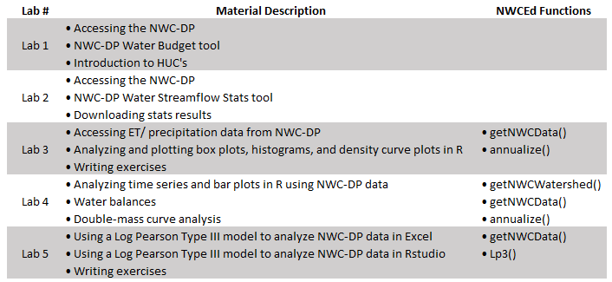

Table 2. Presents an outline of the laboratory exercises and associated NWCEd functions.

The content for each of the labs was developed to support three learning objectives for the hydroscience students. The first learning objective is understanding how to access hydrologic data sets and associated metadata from the NWC-DP. The second objective is learning how to analyze data sets from the NWC-DP using both numerical and graphical methods in R. The third objective is to practice effective communication of data analysis through the use of graphs. A discussion of the correspondence between learning objectives and the provided lab content is provided in the Results section.

3.0 Results

The NWCEd package functions and external R-package functions serve to support the hydrology concepts presented in the NWCEd laboratory exercises. This section describes the relationship between the lab content and the technology incorporated into the labs. Also included in this section is an analysis of the effectiveness of the lab content in meeting the established learning objectives as described previously.

Lab 1 and Lab 2 were designed specifically to instruct students how to navigate through the NWC-DP to access USGS hydrologic data sets. Step-by-step instructions were laid out in Lab 1 and Lab 2 for choosing the desired data sets according to a user-specified HUC or a user-specified USGS stream gage. Lab 1 walks the user through NWC-DP features while Lab 2 teaches the user how to access associated metadata, how to access statistical tools for running analyses in the portal, and how to download the results into Microsoft Excel as shown in Figure 3 below. There is no interactive R technology incorporated into these two labs.

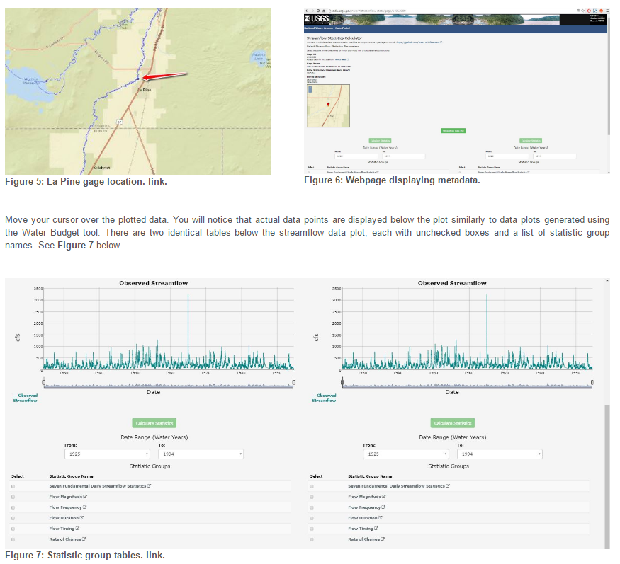

Figure 3. Shows part of Lab 2, which instructs users how to access and run statistics on streamflow data from NWC-DP.

While the first two labs do not have any supporting R code, the other three labs are heavily supported through R technology. These labs assume students have a working knowledge of R and RStudio. Lab 3 focuses on graphical methods in R for analyzing hydrologic data. The graphical methods discussed include box plots, histograms, and density plots.

Box plots were discussed to teach students how to identify outliers in data sets, as well as how to analyze the spread of the data. The cars data set from the built-in data sets R package was also used in connection with ggplot2 to provide a box plot with non-uniform spread, allowing students to more easily visualize the attributes of the data set. In addition, ggplot2 was used to provide labels to the box plot that corresponded to the content discussed in the lab. The R package gridExtra was applied during the box plot section of Lab 3 to compare box plots side by side (Baptiste 2016).

A discussion on using histograms to analyze hydrologic data was also presented in the content for Lab 3. The ggplot2 and gridExtra packages were used to compare several histograms of evapotranspiration data side by side, each with varying band widths as shown in Figure 4 below.

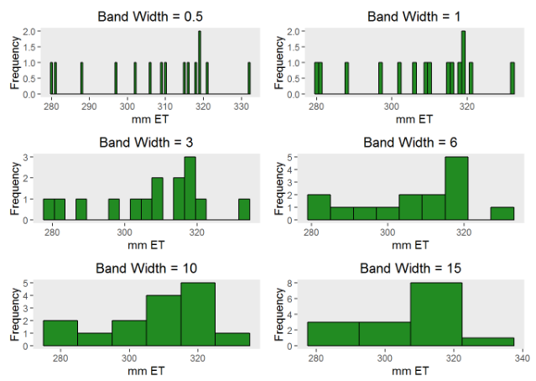

Figure 4. Shows an example of histogram band widths, which are compared in Lab 3.

With all of the histograms plotted side by side and effectively labeled, students are able to see the effect that band width has on histograms. This example is expected to help students make more informed decisions about how they represent their data.

Lab 4 content teaches general principles related to water balances. An interactive map is used to support the water balance concept by allowing the students to view the physical nature of their watershed with the getNWCWatershed function from the NWCEd package and the leaflet package as described previously. Time series plots produced using ggplot2 allow students to view actual data sets from the NWC-DP and track the current state of the water balance for their selected watershed. Figure 5 below contains a time series plot from Lab 4 containing evapotranspiration, precipitation, streamflow, and calculated water storage levels.

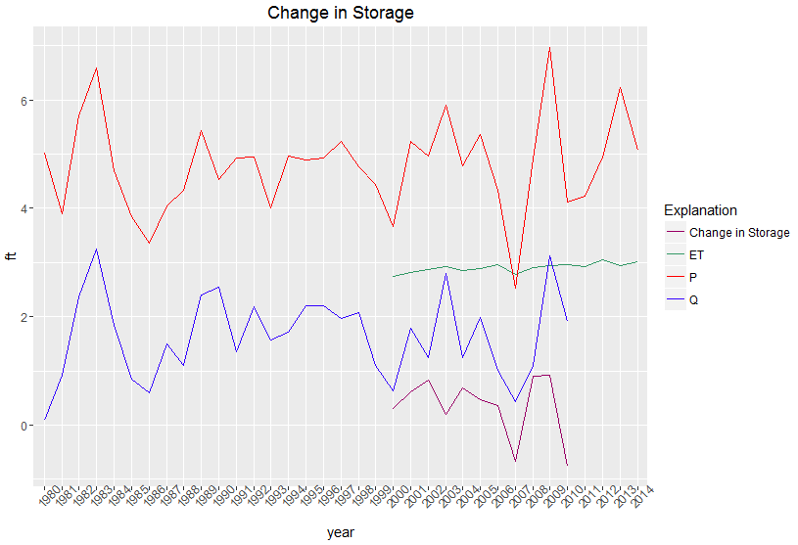

Figure 5. Shows example plots from Lab 4, which instructs users how to visualize NWC-DP time series data to improve their understanding of the water budget concept.

Lab 4 also uses the dplyr package (Wickham 2016) in tandem with ggplot2 to produce a color-filled histogram with bars above the axis referring to a gain in storage and bars below the axis referring to a loss in storage. By using different plot types, students’ awareness and understanding of a water balance can be increased, as well as their methods to communicate water balance information in the future.

Numerical analyses are introduced in Lab 4 with the use of double-mass curves. To support the concept, an equation and its variables are presented to educate students on how the analysis is to be done numerically. A series of plotted curves are also used to graphically describe the process. The series of plotted curves is presented below in Figure 6.

|  |  |
| --- | --- |
|  |  |
|  |  |

Figure 6. Shows a double-mass curve analysis as visualized in Lab 4 using NWC-DP data.

The use of different colors helps students better visualize the adjustment they have made to their data set to correct for error. Showing only the final, corrected line would not adequately help students recognize the significance of the adjustment to the data. Plotting the curves in sequence along with both the uncorrected and corrected data together improve the understanding of the method used to perform the adjustment as well as the significance of the change made.

Lab 5 incorporates Microsoft Excel and its PivotTable feature in a step by step tutorial on calculating a Log-Pearson Type III distribution for a hydrologic data set from the NWC-DP. The data sets from the NWC-DP are very large, which makes the steps for performing the distribution challenging. After walking the students through the lengthy process, the lab then shows students an alternative method using the custom Lp3 function in the NWCEd package.

This process allows students to learn the individual steps of calculating a distribution before using R functions to perform the same calculation. This process also helps students see the benefit of using the Lp3 function in that students are able to download large data sets directly into their instance of RStudio and then perform the analysis, saving them time.

It is important to note that for each of the features of the labs described above, there is a viewable block of code that can be copied and pasted directly into an instance of RStudio. This allows for the reproduction of each graph, interactive map, and curve shown in the labs. These code blocks allow students to familiarize themselves with the components and functions used to produce the associated content as shown in Figure 7, Figure 8, and Figure 9.

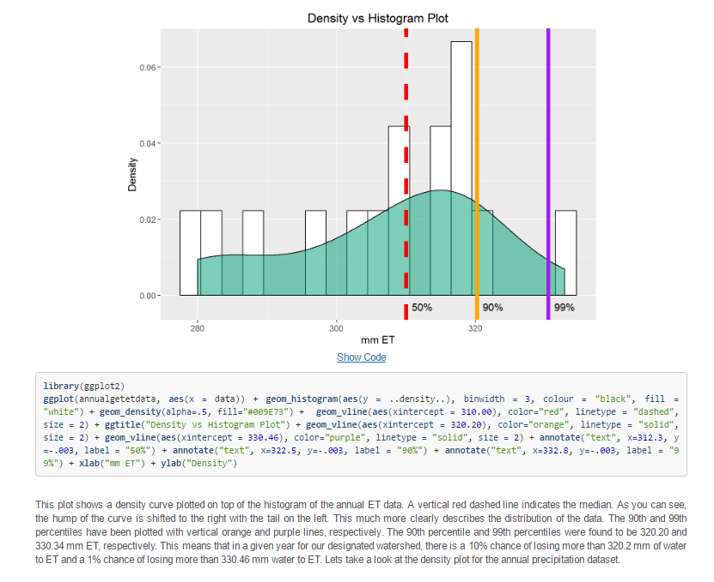

Figure 7. Shows and example of how code has been provided to reproduce density curve plots, including the manual adjustment of labels and percentile lines.

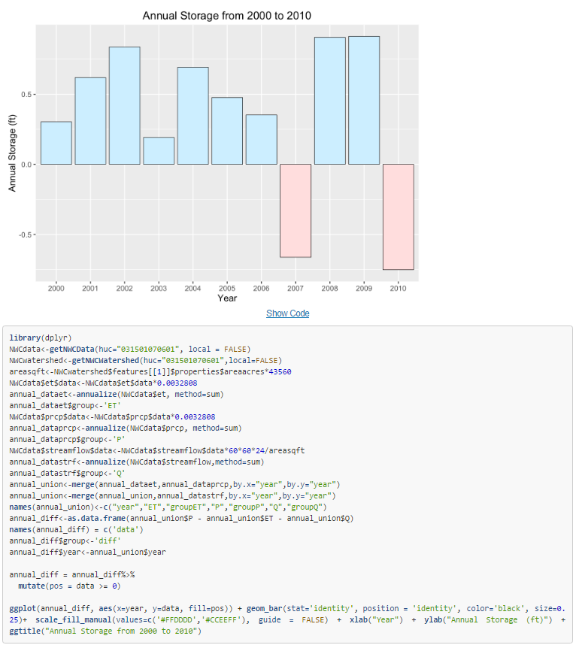

Figure 8. The code for a histogram with positive and negative bars is provided to introduce an alternative way to visualize water storage.

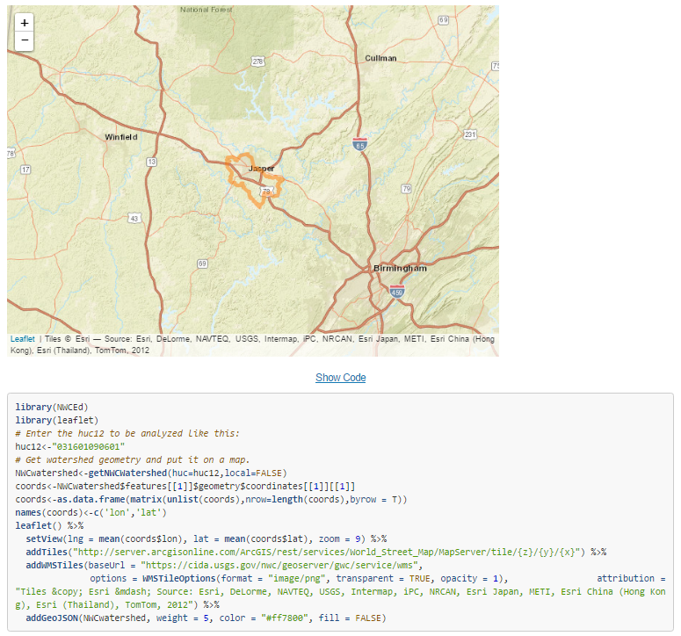

Figure 9. Code is provided to replicate interactive maps in the user’s local instance of RStudio.

Students who are permitted to study and produce their own code for the associated hydrology topics will be better prepared for more advanced coursework related to hydrology and hydroinformatics.

We established three learning objectives for the content of the laboratory exercises. Learning Objective 1 is for students to understand how to access the NWC-DP including the associated data sets and tools. Learning Objective 2 is for students to learn how to analyze NWC-DP data using both numerical methods and graphical methods in R. Learning Objective 3 is for students to practice communicating the results of their analyses using graphs.

The R code and labs were posted to <https://github.com/USGS-R/NWCEd> and are available for download and use as public domain resources.

4.0 Conclusion and Discussion

The NWCEd R package and associated labs were developed to accomplish two objectives. The first was to promote hydrologic data from the NWC-DP. The second was to incorporate new R technology into current hydrology curriculum to better prepare students for future work in hydrology and hydroinformatics.

The NWCEd package contains custom functions that allow users to install hydrologic data sets directly from the NWC-DP into their instance of RStudio for viewing and analyzing. The NWCEd package works in tandem with several pre-existing packages hosted on CRAN. There are 5 laboratory exercises developed to teach students about hydrology concepts with hands-on examples using NWC-DP data in RStudio.

The NWCEd package and associated laboratory exercises are intended to be used as stand-alone material to support hydroscience courses, such as undergraduate hydrology and hydroinformatics. This design allows educators to have flexibility in selecting lab content that supports their current curriculum. Because the content is self-teaching, instructors do not need to be expert in programming in R. Additionally, the lab content is designed to be used outside of the classroom. This relieves the educator from needing special technology in the classroom.

There exist limitations associated with the laboratory content and NWCEd package. As mentioned previously in this paper, the materials do require a working knowledge of RStudio. Educators and students can seek open source instruction on downloading and installation of R and RStudio (<https://www.rstudio.com/products/rstudio/download/>). Students must have access to a computer and internet in order to access and use the materials.

There is a need for follow up evaluation to determine how effective these tools are at educating students on the NWC-DP, data acquisition through the NWC-DP and R, and improving current understanding of hydrology concepts through applying new technology. Continued research may help to determine the confidence of students in beginning hydrologic data analysis after completing the materials. Finally, an assessment to determine how the materials are received and used by hydrology and hydroinformatics educators could be used to help improve their utility in the future.

Potential outreach activities for these tools include a CUAHSI webinar. We expect in the near future to post this material on the NWC-DP as well as CUAHSI’s website. As an open-source project, this material is available to the public to update and reuse and access through GitHub. The USGS is repsonsible for maintaining the code for the forseeable future.

Acknowledgements

This work was funded by the USGS under award number 200251-00001-176 (G16AP00110). We gratefully acknowledge the contributions of individual scientists at the USGS Office of Water Information. Any use of trade, firm, or product names is for descriptive purposes only and does not imply endorsement by the U.S. Government.

Software Availability

NWCEd, Version 1.0, David Blodgett, Jake Nelson, Software is in Public Domain, Available starting November 15, 2016, Retrievable at <https://github.com/USGS-R/NWCEd>.

References

Ames, D., J. Horsburgh, J. Goodall, T. Whiteaker, D. Tarboton & D. Maidment, (2009), Introducing the open source CUAHSI Hydrologic Information System desktop application (HIS Desktop). In: 18th World IMACS Congress and MODSIM09 International Congress on Modelling and Simulation, Modelling and Simulation Society of Australia and New Zealand and International Association for Mathematics and Computers in Simulation. p 4353-4359.

Baptiste, A., Anton, Antonov, (2016). gridExtra: Miscellaneous Functions for "Grid" Graphics. 2.2.1 edn.

Blodgett, D. L., 2011. Geo Data Portal Spatial Data Infrastructure Documentation.

Brazil, L., Pollak, J., 2016a. Downloading Discharge and Precipitation Data from HydroClient and Interpreting it with Graphs in Excel. In: Consortium of Universities for the Advancement of Hydrologic Science, Inc. <http://serc.carleton.edu/hydromodules/steps/114767.html> Accessed November 21 2016.

Brazil, L., Pollak, J., (2016b). Investigating Air Temperature with HydroClient and RStudio. In. <http://serc.carleton.edu/hydromodules/steps/120944.html> Accessed November 21 2016.

Butler, H., M. Daly, A. Doyle, S. Gillies, T. Schaub & C. Schmidt, (2008). The GeoJSON format specification. Rapport technique:67.

CUAHSI, CUAHSI Third Biennial Science Meeting Updates-" Fusing Science and Solutions" July 16-18, 2012-Boulder, CO. In: Workshop-Penn State University, 2012.

Erl, T., 2004. Service-oriented architecture: a field guide to integrating XML and web services. Prentice Hall PTR.

Graul, C., 2016. leafletR: Interactive Web-Maps Based on the Leaflet JavasScript Library. 0.4-0 edn.

Hanken, J., 2013. Biodiversity online: toward a network integrated biocollections alliance. BioScience 63(10):789-790.

Hutton, C., T. Wagener, J. Freer, D. Han, C. Duffy & B. Arheimer, Most computational hydrology is not reproducible, so is it really science? Water Resources Research:n/a-n/a doi:10.1002/2016WR019285.

Jirka, S., A. Bröring, P. Kjeld, J. Maidens & A. Wytzisk, 2012. A lightweight approach for the sensor observation service to share environmental data across Europe. Transactions in GIS 16(3):293-312.

Keim, R. F., C. Kendall & A. Jefferson, 2014. The expanding utility of laser spectroscopy. Eos, Transactions American Geophysical Union 95(17):144-144.

Merwade, V. & B. L. Ruddell, 2012. Moving university hydrology education forward with community-based geoinformatics, data and modeling resources. Hydrol Earth Syst Sci 16(8):2393-2404 doi:10.5194/hess-16-2393-2012.

Morsy, M. M., J. L. Goodall, A. M. Castronova, P. Dash, B. Miles, V. Merwade, J. M. Sadler & D. G. Tarboton, 2016. Design and Implementation of Hydrologic Model Sharing Capabilities within the CUAHSI HydroShare System.

Peng, Z.-R. & C. Zhang, 2004. The roles of geography markup language (GML), scalable vector graphics (SVG), and Web feature service (WFS) specifications in the development of Internet geographic information systems (GIS). Journal of Geographical Systems 6(2):95-116.

Popescu, I., A. Jonoski & B. Bhattacharya, 2012. Experiences from online and classroom education in hydroinformatics. Hydrol Earth Syst Sci 16(11):3935-3944 doi:10.5194/hess-16-3935-2012.

R-Core-Team, 2016. R: A Language and Environment for Statistical Computing. In. https:// Accessed November 23, 2016 2016.

RStudio-Team, 2015. RStudio. 3.2.5 edn.

Ruddell, B. L. & T. Wagener, 2013. Grand challenges for hydrology education in the 21st century. Journal of Hydrologic Engineering 20(1):A4014001.

Sanchez, C. A., B. L. Ruddell, R. Schiesser & V. Merwade, 2016. Enhancing the T-shaped learning profile when teaching hydrology using data, modeling, and visualization activities. Hydrol Earth Syst Sci 20(3):1289-1299 doi:10.5194/hess-20-1289-2016.

Simley, J. D. & W. J. Carswell Jr, 2009. The national map—hydrography. US Geological Survey Fact Sheet 3054(4).

Tarboton, D., J. Horsburgh, D. Maidment, T. Whiteaker, I. Zaslavsky, M. Piasecki, J. Goodall, D. Valentine & T. Whitenack, Development of a community hydrologic information system. In: 18th World IMACS Congress and MODSIM09 International Congress on Modelling and Simulation, Modelling and Simulation Society of Australia and New Zealand and International Association for Mathematics and Computers in Simulation, 2009. p 988-994.

Tarboton, D., R. Idaszak, J. Horsburgh, J. Heard, D. Ames, J. Goodall, L. Band, V. Merwade, A. Couch & J. Arrigo, HydroShare: advancing collaboration through hydrologic data and model sharing. In: International Environmental Modelling and Software Society (iEMSs) 7th International Congress on Environmental Modelling and Software, San Diego, California, USA www.iemss.org/society/index/php/iemss-2014-proceedings, 2014.

Tarboton, D. G., D. Maidment, I. Zaslavsky, D. Ames, J. Goodall, R. P. Hooper, J. Horsburgh, D. Valentine, T. Whiteaker & K. Schreuders, Data Interoperability in the Hydrologic Sciences. In: Environmental Information Management Conference, Santa Barbara, CA, USA, 2011.

Thompson, S. E., I. Ngambeki, P. A. Troch, M. Sivapalan & D. Evangelou, 2012. Incorporating student-centered approaches into catchment hydrology teaching: a review and synthesis. Hydrol Earth Syst Sci 16(9):3263-3278 doi:10.5194/hess-16-3263-2012.

Wagener, T., C. Kelleher, M. Weiler, B. McGlynn, M. Gooseff, L. Marshall, T. Meixner, K. McGuire, S. Gregg, P. Sharma & S. Zappe, 2012. It takes a community to raise a hydrologist: the Modular Curriculum for Hydrologic Advancement (MOCHA). Hydrol Earth Syst Sci 16(9):3405-3418 doi:10.5194/hess-16-3405-2012.

Wanielista, M., R. Kersten & R. Eaglin, 1997. Hydrology: Water quantity and quality control. John Wiley and Sons.

Wickham, H., 2009. ggplot2: Elegant Graphics for Data Analysis. Springer-Verlan New York.

Wickham, H., Francois, Romain, RStudio, 2016. dplyr: A Grammar of Data Manipulation. 0.5 edn.

Xie, Y., 2016. knitr: A General-Purpose Package for Dynamic Report Generation in R. 1.15.1 edn.